Graphic Organizer – Article
Family and Consumer Sciences Example

Read this article about the Liebeck versus McDonald’s lawsuit. Use this graphic organizer to take notes while you read the article. After you have completed this graphic organizer, use it to write a half-page summary of the article.

WHO is involved?
WHEN did this occur?
WHERE did this occur?

WHAT happened first?
WHAT happened next?
WHAT happened last?

WHY did this happen?

SO WHAT is next?

Based on the information that you read, how did you think this case impacted the food and beverage industry? What do you think will happen in the future to protect businesses from similar lawsuits?

Sentence Starters for Reader Response
Agriculture Example

For today’s warm-up activity, watch the video from YouTube called Sport Science: Turf vs. Grass. Use the information from the video and your notes from yesterday on turf to write a paragraph (5 – 10 sentence) response. What do you think? Do you agree with this decision? Please use the sentence starters below, if needed.

I’ll bet that…
If______ happens, then…

I like/don’t like ______ because…
This could be more effective if…
One big difference between _______ and _______ is…

So, the big idea is…
A conclusion that I’m drawing is…
This is relevant to my life because…

At first, I thought ______, but now…

Creative Questions Starters
Health Science Example

Read the infographic and article about the Zika Virus. The infographic is from the World Health Organization’s website; it provides basic information about the virus. The article is very short and talks about the recent spread of the virus in Florida. Write four questions that you have about the Zika virus using the question starters below:

Why…?
What are the reasons…?
What if…?
What is the purpose of…?
How would it be different if…?
Suppose that…?
What would change if…?

1.

2.

3.

4.

Claim, Evidence, and Reasoning Framework
Business Example

Before completing your assignment on banking, let’s review the Claim-Evidence-Reasoning framework. Remember that the claim is your answer to the question. Evidence is the proof that your answer is true. Examples of evidence include concrete facts from the article, word problem, scenario, textbook, pictures, class notes, movie, laboratory experiment, etc. The reasoning statement explains WHY or HOW the evidence supports the claim.

Here is a simple example: Which is healthier - a slice of pepperoni pizza or fried chicken sandwich?

Claim | Pizza is a healthier than the chicken sandwich.
Evidence | Pizza is made with tomato sauce and cheese.
Reasoning | The tomatoes used to make the sauce are an excellent source of vitamins and the cheese contains calcium. The sandwich does have any of these nutrients.

Legitimate Business Transition or Banking Fraud

I am selling a bike frame on Craigslist for $350. This guy named Mark Dowell contacted me to buy the bike. He said that he would send me a certified check via overnight courier. The check would cover the $350 for the bike frame, as well as shipping costs. He told me to cash the check and then he would arrange for a shipping agent to pick up the bike (as is).

The next day a regular check arrived by courier. Instead of being $350 it was for $1,950! There was a note attached to the check – “I’ve enclosed a personal check from my business account instead of a certified check. No worries. This check from my business account is guaranteed, unlike a certified check but you can’t cash it for 15 days. That’s why I added the extra money for the inconvenience of waiting 15 days. Please send the bike frame ASAP. Thanks.”

Here is the check that I got in the mail:
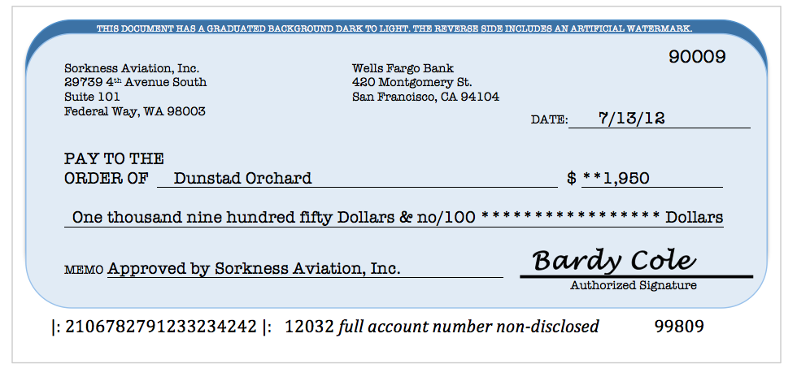

Please help Mr. Dunstad Orchard determine if this is a legitimate business transition or banking fraud. Use this framework to organize your answer. You must include at least three pieces of evidence. Remember to explain why this evidence supports your answer. You may use your notes on banking to complete this assignment.

Claim:

Evidence: | Reasoning:
Conclusion:

